OFA Board Meeting
Oct. 21, 2021
10am Pacific time
- Roll Call:
Board Members:
At-Large / Harold Cook
HPE / John Byrne
Huawei / Daqi Ren
IBM / Bernard Metzler
Intel / Phil Cayton
LLNL / Matt Leininger
Mellanox / Gilad Shainer
Oak Ridge / Chris Zimmer
Sandia / Mike Aguilar

Others:
Jim Ryan
Paul Grun
IBM/Red Hat / Doug Ledford
Intel / Tatyana Nikolova

- Opens, Agenda Bashing

- Treasurer Update

  - $113,375 cash position on 30 September. Accumulated surplus decreased to $95,286. Net income was reported as -$609.
  - After SC21, we will have a cash position around $90K.

- Approve Board minutes from Sep. 16, 2021

- A motion was made to approve the Board minutes from September 16, 2021. The motion was made by Michael Aguilar (Sandia) and seconded by Bernard Metzler (IBM).

- Results of the Bylaws vote

- No quorum, yet.
- 3 promoter members are in.
- The 3 National Labs are waiting back from their legal departments for their promoter positions.
- 1 non-promoter member is in.
- We will need 3 more members.

- SC21 update

- Kiosk
  - Doug Ledford, Richelle Ahlvers
    - 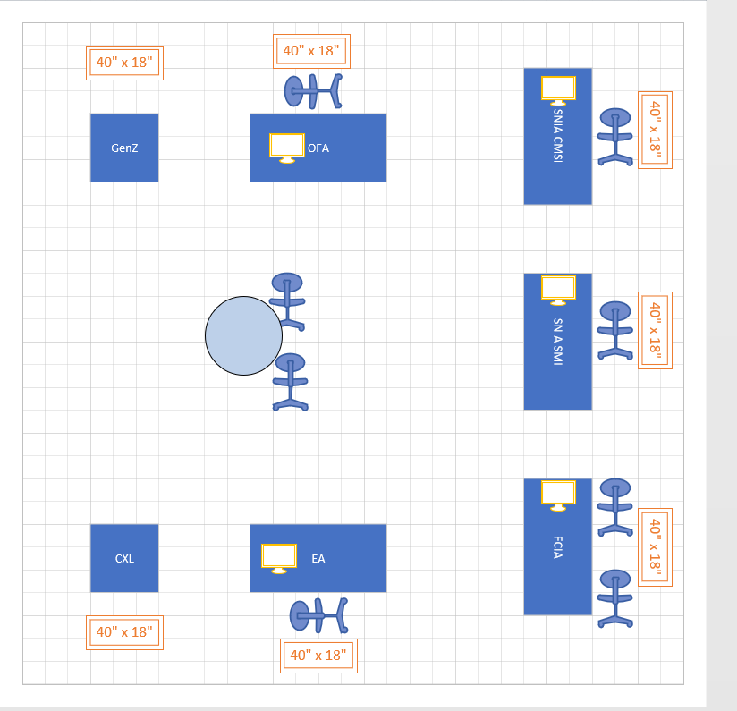

  - 2M White cabinet (2M x .5M x 1M)
  - OFA cabinet drape
  - White barstool
  - (1) 500W 120V outlet
  - (1) power strip
  - (1) 40” monitor
  - (1) Divider panel with graphics (40"L x 1.5"W x 72"H)
  - Graphics 34 7/8” x 69”H
  - Passes: 7 exhibitor passes, 15 guest passes (exhibit only)
  - Network access via wifi
- OFMF SC21 BoF-- Tuesday, 16 November, at 12:15 pm Central Time
  - Solving the Fabric Management Gordian Knot
  - Mike Aguilar, Phil Cayton, Russ Herrell, Richelle Ahlvers, Jim Hull, Erich Hanke
- Other BoFs of note from members and collaborators:
  - Infiniband In-Network Computing Technology and Roadmap (Gilad Shainer and Panda Dhabaleswar)
  - UCX Community (Gilad Shainer)
  - CXL Consortium, Gen-Z Consortium, SNIA, and End Users (Kurt Bowman, Scott Shadley)
- Doug Ledford will be using the discretionary funds for his hotel stay.

- FSDP update

- We have the FSDP cluster built and up and running, that was phase 1.
- We will be starting phase 2 and notifying members that the FSDP is available to them.

